Here’s what a digital marketing action plan should look like – Showcase what a good digital marketing action plan by Convergence looks like.

Key Info & Notes
Full length DM action strategy - https://stevenjwilson.com/digital-marketing-action-plan/
Brief facts on DM action strategy - https://www.descript.com/blog/article/how-to-build-a-digital-marketing-strategy-and-action-plan
Step-by-step guide - https://www.wearemarketing.com/blog/a-step-by-step-guide-to-structuring-a-digital-marketing-plan.html
Structure
Intro
What is a digital marketing strategy?
Items in a perfect action plan
Follow up action
Conclusion

Here’s what a digital marketing action plan should look like
Every business in the world would need to make the world aware of their product or services. And to do that, they would need a marketing strategy. Think of the businesses around you, from the banks to the supermarket near you. Each of them employs a marketing strategy for their product or service that they’d like a customer to pay for. Most likely, that strategy involves using digital channels to advertise their existence and convince consumers to buy their products.
In digital marketing, the goal is the same, but the technologies are exclusively digital. Digital marketing often involves understanding your audience, setting SMART goals, using the appropriate tools, analysing your online presence, producing content, launching your campaign, and optimizing it. Does it feel overwhelming? Hold your breath because a digital marketing strategy is just one component of a marketing plan. But that is not what we are looking at in this article. Through this topic, we will delve into what a digital marketing strategy is, along with what we think constitutes a good digital marketing action plan. Because without a digital marketing action plan, you’ll miss out on the opportunity to grow your customer base.
What is a digital marketing strategy?
The aim of your digital marketing strategy is to achieve the goals you have set for your business. Goals are crucial here since their implementation will revolve around them or multiple goals. A digital marketing strategy should work towards your business goals through various actions. Ideally, companies should examine both their goals and their customers before choosing a mix of paid, earned, and owned media.
You may be thinking, “This seems rather tedious, and I don’t think it is necessary for my business.” It may seem true if you’re a small business or a professional developing your brand, but a digital marketing strategy can do so much more, it can:
- Make your product or service amazing by attracting, convincing, converting, and winning over your customers.
- Helps to plan all your strategies and actions to reach out to your target audience.
- Provide value at every stage by segmenting your marketing campaigns.
Before you start to think about your digital marketing strategy for your business, there should be 3 crucial pillars in the strategy:
- User Journey
The User Journey describes a potential customer’s interaction with a brand from discovery to loyalty. Think of the marketing funnel, which outlines the stages of customer engagement, such as awareness, interest, desire, and action.
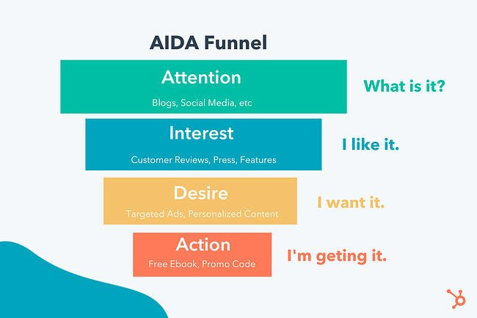
The image is taken from Hubspot.
- Marketing Channels
Companies use marketing channels to reach out to their customers at different touchpoints. Social media, referral traffic through websites, organic searches (from Google search engine), paid search ads, and email marketing is some examples.
- Content
Content placed on the channels is quite motivated by the first 2 mentioned pillars. Once you get familiar with your customer and how they’ll engage with your business, you can get to the essentials of creative content (blogs, videos, infographics) and their formats (ad banners, video ads, text ads).
Here’s how your digital marketing action plan should look like
Now that you’re aware of what a digital marketing strategy is, we’ll break down what makes a good digital marketing action plan in our opinion. To start, here’s a summary of the action plan steps:
- Understand your audience
- List your marketing objectives to detect KPIs
- Prepare a strategic plan
- Execute the plan
- Evaluate and Analyse

Understand your audience
Would you approach a random stranger at a party? Even if you are a social butterfly by nature, you would need certain social cues to help you understand more about the person you are going to talk to. Likewise, when creating a marketing action plan, it is important to understand your business’s target audience. An effective plan requires knowing who they are, where they hang out, what their needs and problems are, and other vital details. Where can you find these data? By doing market research.
The purpose of market research is to get as much information as possible about your prospects, which can be used to build buyer personas. Here are some methods that can help gather information on your prospects.
- Work with your company’s sales team
- Gather data via analytics tools
- Conduct social listening
- Carry out a quantitative survey
- Interview willing participants (qualitative research)
Once you’ve done the market research, the next step is to build your buyer’s persona based on the researched data that you’ve gathered. The key to building a buyer’s persona is to be as specific as you can be. What is their name? What social media platform do they use? Do they have a goal in life? These questions can help form your buyer’s persona which can guide you to create a better targeted messaging.
List your marketing goals to detect KPIs
To give you an idea, here are some examples of goals that marketing teams come up with.
- Improve conversion rates
- Drive more click-throughs on paid ads
- Increase website traffic
- Get more social media engagement
- Grow an email newsletter list
It is important to note that your marketing goals should be aligned with your business goals. Your marketing goals should help you get closer to your business goals. Once you’ve defined your marketing goals, you need to specify them further by setting KPIs. The key performance indicators (KPIs) of digital marketing help companies track their results and set expectations. Various metrics can be tracked by a company, including sales, leads, or even how long a potential customer spends browsing your site. When you’re setting your KPIs, remember this: they should be SMART: Specific, Measurable, Attainable, Relevant, and Timely. Before you begin your campaign, determine the KPIs you'll use to measure your success.
Prepare a strategic plan
Formulate your plan by evaluating your existing digital vehicles-that is, where and how you will place ads or content (on which websites or social media accounts). After that, you can decide if you will use owned, earned, or paid media across these vehicles to diversify your marketing mix. For example, a company's digital assets are the websites and accounts it owns, earned media is the publicity it receives through positive press or reviews, and paid media is the channels through which it advertises. You need to plan out how you will take advantage of each lever. Take for example using a press release and launch event combined with news ads about your product, you could get articles written about your new product to help drive sales.
Execute the plan
Once you've done the research and work, it's time to put everything into practice. Expect this to take days, weeks, months, or even years to complete. You can also be resourceful by starting up your channels and then cross-promoting them such as promoting a new website over social media.
Evaluate and Analyse
Once your channels are up and live, it’s not the end, you’ll need to do something very important: track the success. Did the plan manage to meet your goals? If not, what can be done to better it? Based on how the market responds, adjust your initial strategy as needed. Paying for media might become easier if owned and earned media are booming. Be open to experimentation, there may not be a one-size-fits-all approach. Keep testing and monitoring so long as it helps you effectively meet your marketing and business goals.
If you’re looking for a dedicated team to develop a digital marketing action plan for you or your clients, look no further than Convergence Concepts. We have the skills when it comes to experience design, strategy, creative and digital media. Feel free to reach out to us at marketing@convergenceconcepts.com.sg with your inquiries.

